 | XS | S | M | L | XL | XXL
MAN | 29 | 30-31 | 32 | 33-34 | 36 | 38
WOMAN | 27 | 28 | 29-30 | 31 | 32 | -

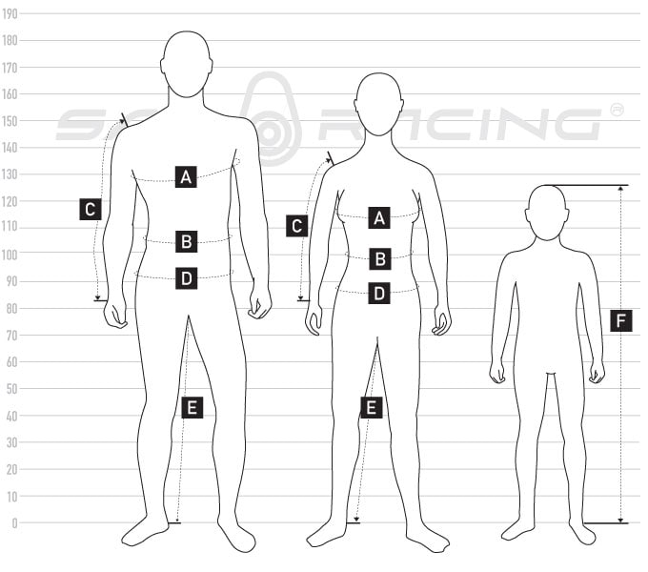
 |  | XS | S | M | L | XL | XXL
 | CHEST | 86,0 | 92,0 | 98,0 | 104,0 | 110,0 | 116,0
 | WAIST | 70,0 | 76,0 | 82,0 | 88,0 | 94,0 | 100,0
 | SLEEVELENGTH FROM SHOULDER | 59,5 | 61,0 | 62,5 | 64,0 | 65,5 | 67,0
 | HIP APROX. 20 CM FROM WAIST | 89,0 | 95,0 | 101,0 | 107,0 | 113,0 | 119,0
 | INSEAM | 77,5 | 79,0 | 80,5 | 82,0 | 83,5 | 85,0
 |  | XS | S | M | L | XL
 | CHEST | 80,0 | 86,0 | 92,0 | 98,0 | 104,0
 | WAIST | 64,0 | 69,0 | 74,0 | 80,0 | 86,0
 | SLEEVELENGTH FROM SHOULDER | 58,0 | 59,5 | 61,0 | 62,5 | 64,0
 | HIP APROX. 19 CM FROM WAIST | 89,0 | 94,0 | 99,0 | 105,0 | 111,0
 | INSEAM | 76,0 | 77,5 | 79,0 | 80,5 | 82,0
 | You find our junior sizes in regular height orientated sizes, centilong.

